## Instructions for using the mapping file

You should have a brand new folder[1], named after your specification, in the specifications subfolder of the Bioschemas google docs folder. That folder should contain a copy of this file and a google spreadsheet. Your new spreadsheet looks like this:

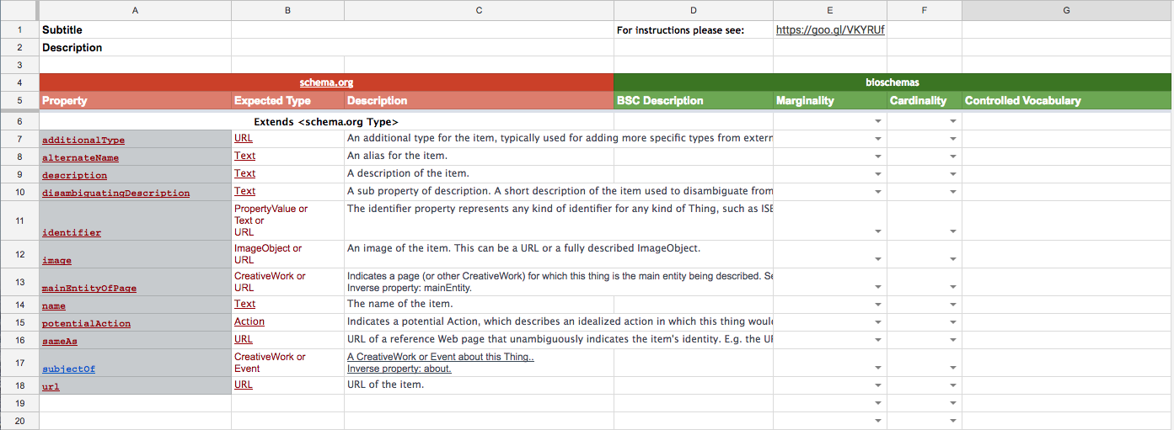

You will find a link to these instructions in cell E1.

To create your specification you must populate the spreadsheet by doing the following:

* Set up the spreadsheet
* Add specialised descriptions, marginalities and cardinalities
* Trigger the generation process

Each step is discussed in-depth below.

### Set up the spreadsheet

**In cell B1** please put a very short description of your new profile. For example, *Specification describing a gene*.

**In cell B2** please enter a longer description of your new profile. Whilst there is no limit on size, please be mindful that it should give a brief overview of why your profile exists and what it covers. A couple of paragraphs should be sufficient.

**In cells A-C6** please enter the name of the Schema.org type on which you have based your specification, e.g., *Course* or *CreativeWork*. If you are unsure of what types schema includes, please familiarise yourself with them: <http://schema.org/docs/full.html>. If this new specification is not based on any pre-existing schema.org type please enter *Thing*.

**Cells A7 - C18** contain the properties of <http://schema.org/Thing>; they have been copied from the schema site and pasted into Cell A-7. Do not edit cells A7 - C18.

Unless your group is basing its specification on <http://schema.org/Thing>, **cell A19** should contain the properties of the schema.org type entered in cells A-C6. Go to the appropriate schema.org web page, select all the properties in that type before copying them and pasting them into A19. You should not copy properties from *Thing*, but all other Types on the page should have their properties copied across.

**In the next available row** start entering brand new properties (i.e., properties that are not found in schema.org). Each property should have a name (in the *Property* field), *Expected Type* (i.e., a schema.org or bioschemas type), but leave the *Description* cell blank.

At the bottom of the page you will see three tabs:

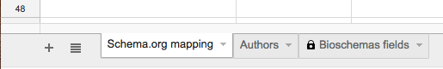

Switch to the *Authors* tab, at which point you will see a new table. Please use this table to record who has contributed to the creation of this specification.



### 

### Descriptions, Marginalities & Cardinal

Switch back to the *Schema.org mapping* tab.

Only those properties for which you specify a marginality and a constraint will appear in the published specification.

Your group must consider each property (i.e., row) individually. Start by classifying each property as one of the following:

* Irrelevant - in which case do nothing, it will automatically be ignored
* Might be useful - use the list box in the *Marginality* cell to select *Optional*
* Probably useful - use the list box in the *Marginality* cell to select *Recommended*
* Essential - use the list box in the Marginality cell to select *Minimum*

Ignoring irrelevant properties, use the *BSC Description* cell to describe how your property should be interpreted from a Bioschema’s perspective. Your group has several options:

* You agree with the schema.org description, and it perfectly describes your intentions: copy the content from the *Description* cell into the *BSC Description* cell.
* You mostly agree with the schema.org description: copy the content from the *Description* cell into the the *BSC Description* cell and edit the *BSC Description*.
* Anything else: write some brand new text in the *BSC Description* cell.

Please do not edit the text in the *Description* cell.

Still ignoring the irrelevant properties, determine how many times each property is needed in a single instance of your specification. You have two options:

* Only once - use the list box in the *Cardinality* cell to select *ONCE*
* May require multiple occurrences - use the list box in the *Cardinality* cell to select *MANY*

Once you have completed the BSC Description, Marginality and Cardinality cells for every relevant property (row) you can switch to the third tab (*Bioschemas fields*) to see exactly what you have selected. If you are happy with your specification you are ready to trigger the generation process.

### Trigger the generation process

If the name of your spreadsheet or gDrive folder has changed please ...

1. If this is not true, please email for assistance.